SUMX funtion :
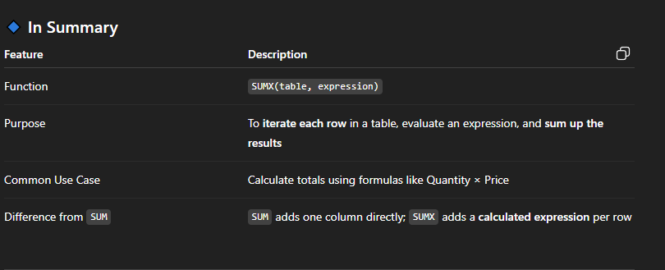

Summarize() :
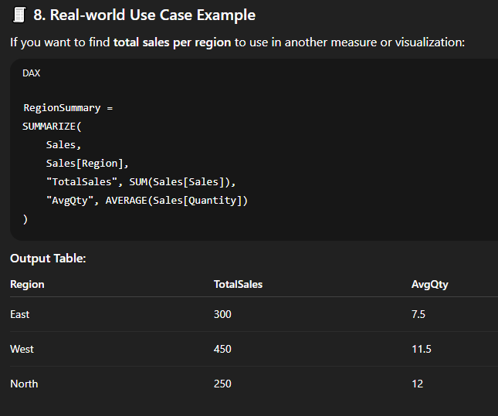

Summarize () VS SummarizeColumns() :
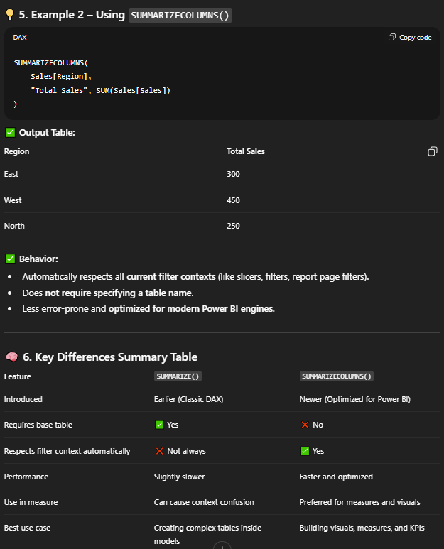
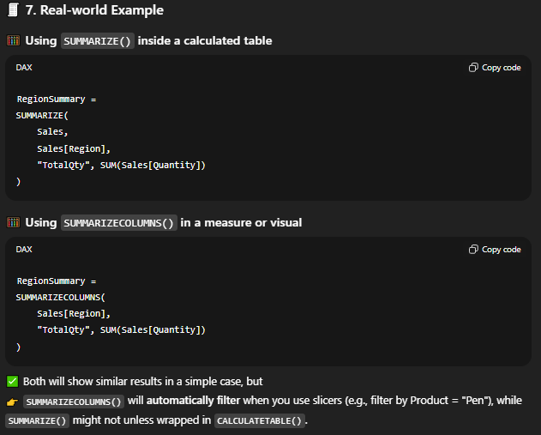
MINX() & MAXX() :
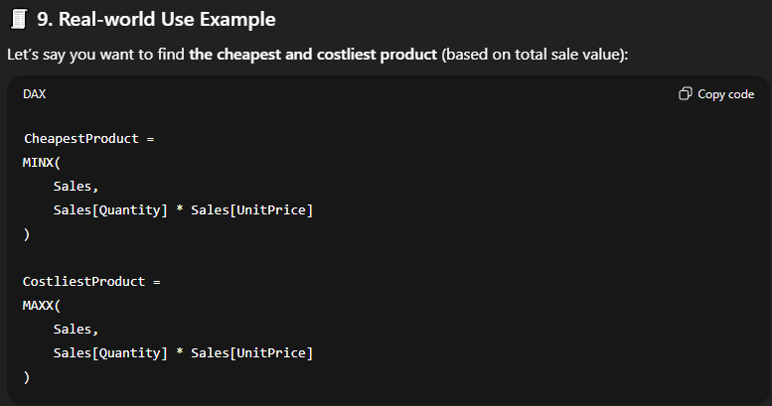
Example - MINX() & MANX()
RegionWiseSummary =
SUMMARIZE(
Sales,
Sales[Region],
"Min Sales", MINX(FILTER(Sales, Sales[Region] = EARLIER(Sales[Region])), Sales[Quantity] * Sales[UnitPrice]),
"Max Sales", MAXX(FILTER(Sales, Sales[Region] = EARLIER(Sales[Region])), Sales[Quantity] * Sales[UnitPrice])
)
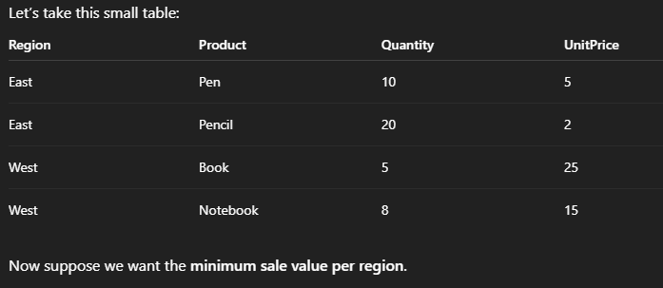
Explanation:
In above code, We are iterating over each row using MINX or MAX function and as we want to calculate the minimum and maximum values of the sales amount for each region therefore to filter for each region and pass that filtered table to the MINX or MAXX function we are using Filter function, and how we will keep the track of the current values of the region as there are multiple region values in the table so for that we have used Earlier() as it will keep a track of the values from the outer level loop which is done by MIX or maAX function as they iterates by each row and executes some expression so to get the current value from that iteration we use the Earlier() function in the DAX function.

MIN() VS MINA() VS MINX()
Min just find the smallest number from the numeric data only whereas mina can find the smallest or minimum values both from numeric and textual values and minx first evaluates some expression rowwise for each row and then it will find the minimum / smallest.

CALCULATE()
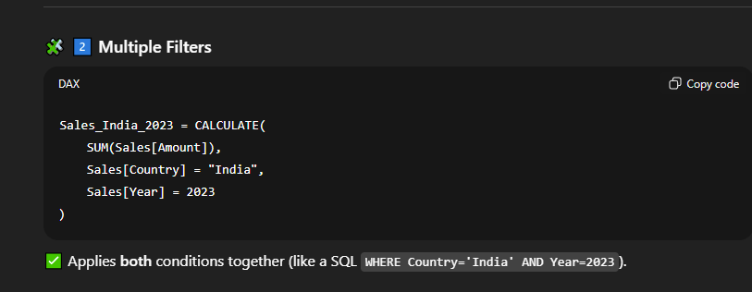
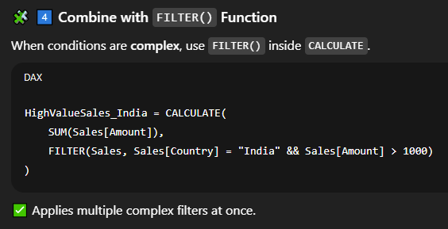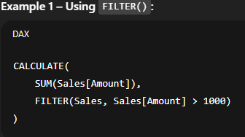

TRUNC() VS ROUND ()
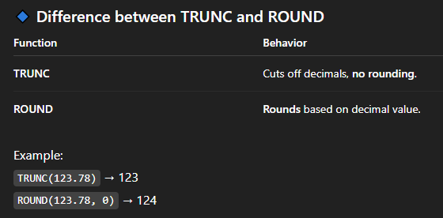

EDATE():
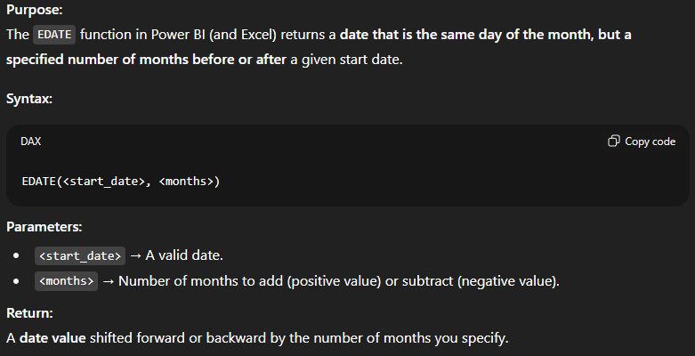
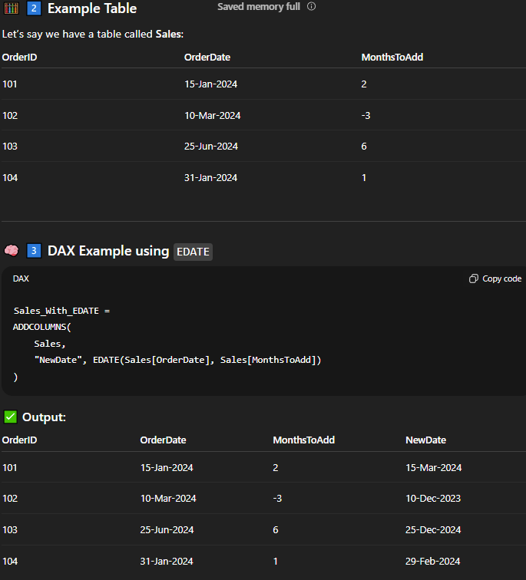
DATEADD():
It doesn’t work on the single date value like EDATE but it works on the whole columns which has date type values.
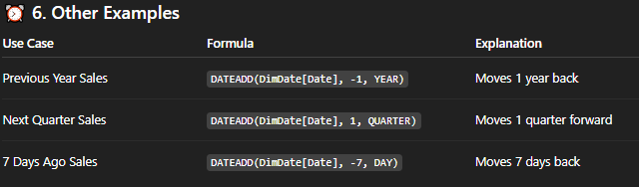
DATE() - YEAR() - Month() - DAY() - FIRSTDATE() - LASTDATE()
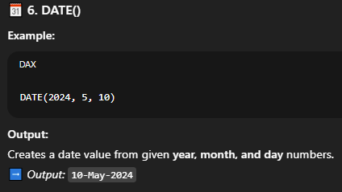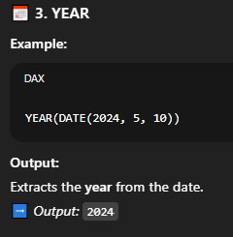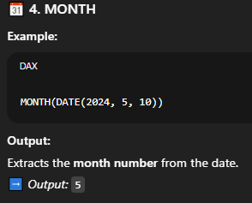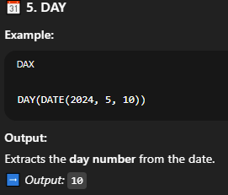
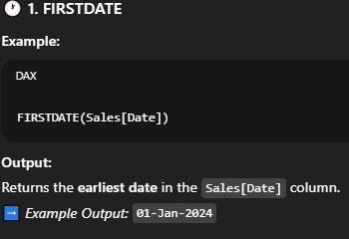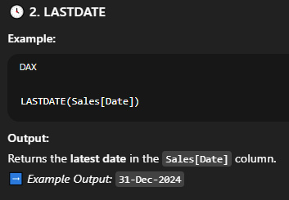
DATEVALUE():
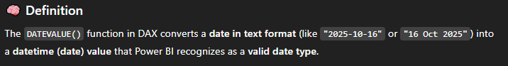
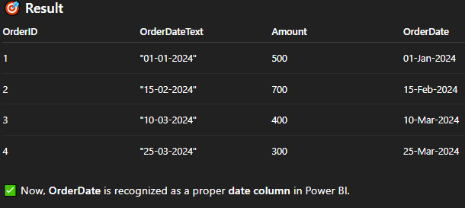
TIME() , HOUR(), Minutes(), Second() , TimeValue():
Same as above Date related functions.
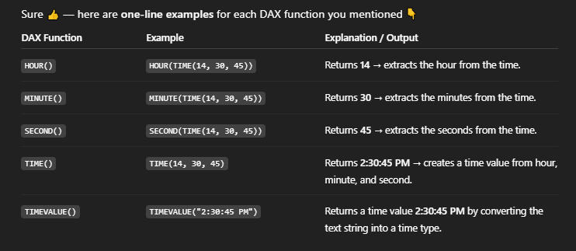

WEEKDAY() VS WEEKNUM()
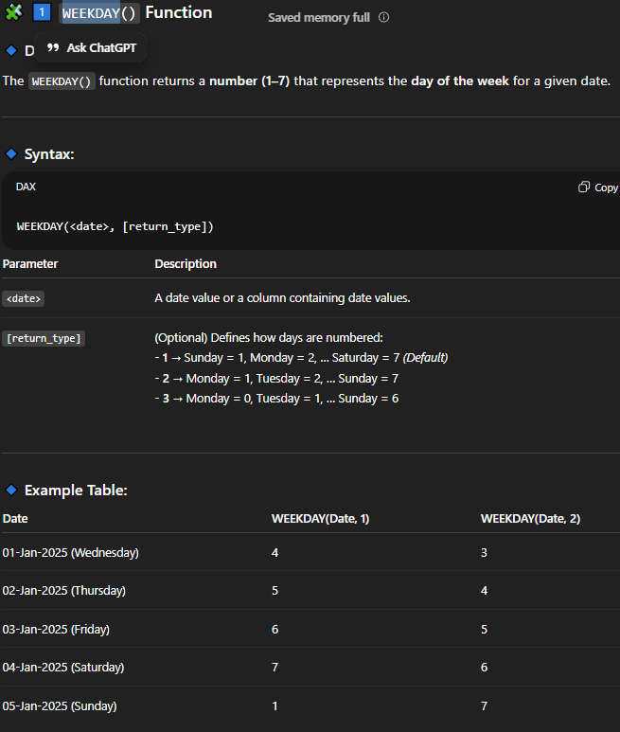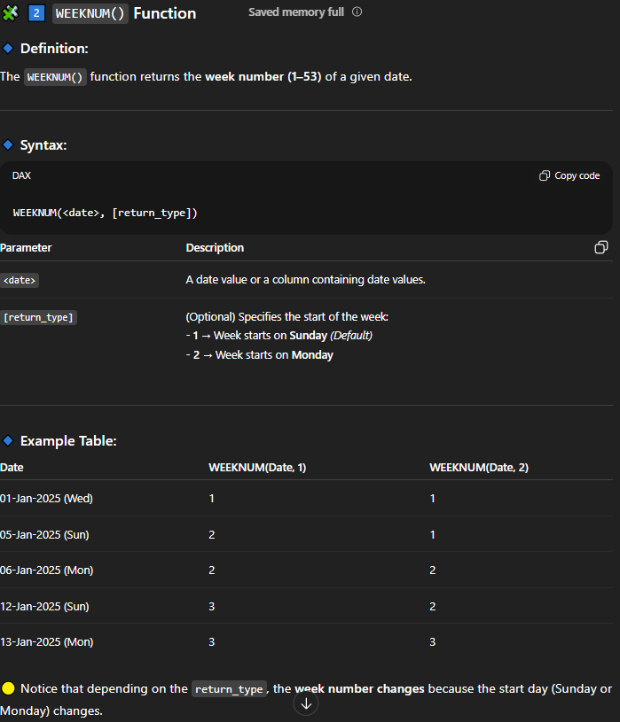

ALL():
use to remove any filter applied on a table or a column by using the ALL function. Majorly used for KPIs which you don’t want to get change even if you select any filter in the report.

Use case (ALL) :
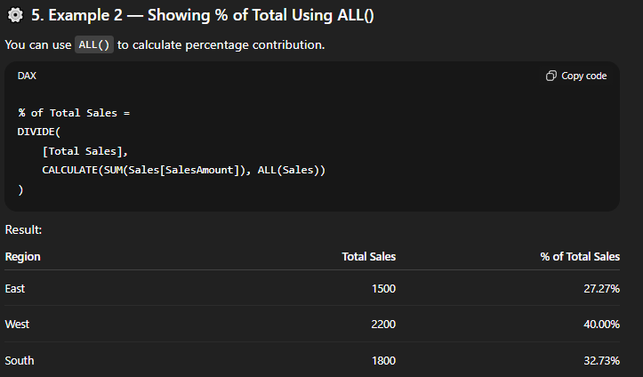
DATATABLE() :
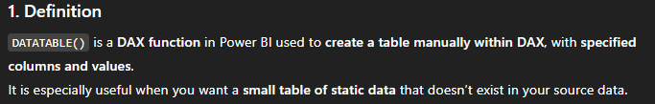
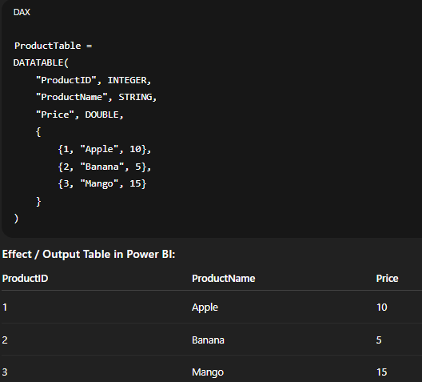
ALLCROSSFILTERED(TableName):
For example, if you have two tables, Sales and Products, with a relationship based on ProductID, a filter applied to the Products table can affect the Sales table. This is because the ProductID in the Products table filters the rows in the Sales table where the ProductID matches.
To Prevent Cross FIltering, use the ALLCROSSFILTERED DAX FUNCTION and majorly use for KPIs.

EXCEPT ():
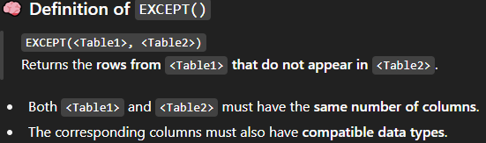
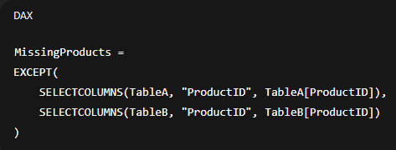

ALLEXCEPT():
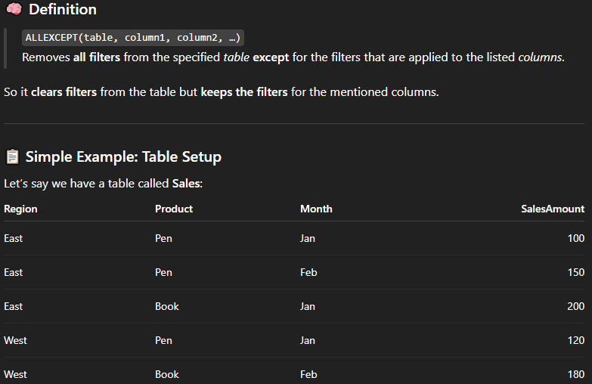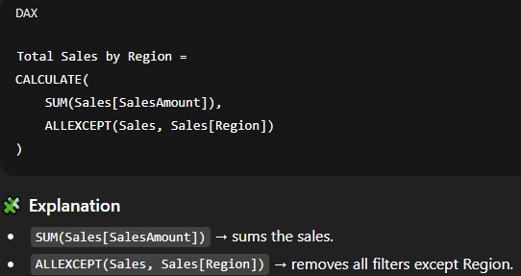

ALLSELECTED():
It only respects the script level filter and any other external filters like slicers/page Level/Report Level Filters but will explores any visual level filters which are applied based on the dimensions used in the visual and calculate the measures for each row filtering row values – this row level values filter doesn’t respect by ALLSELECTED ().
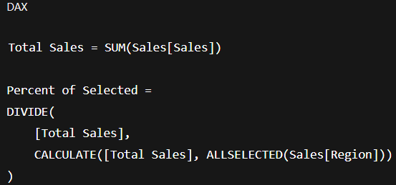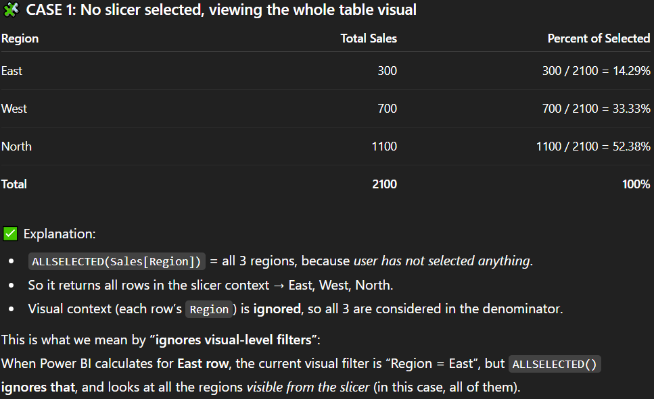
KEEPFILTERS():
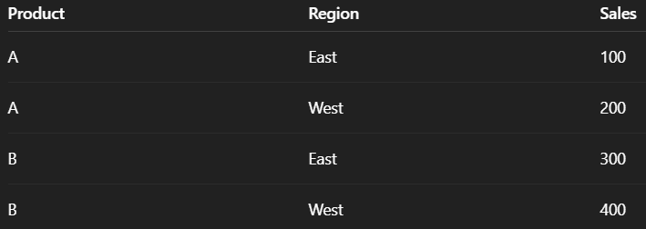
W/O KEEPFILTERS (): With KEEPFILTERS():
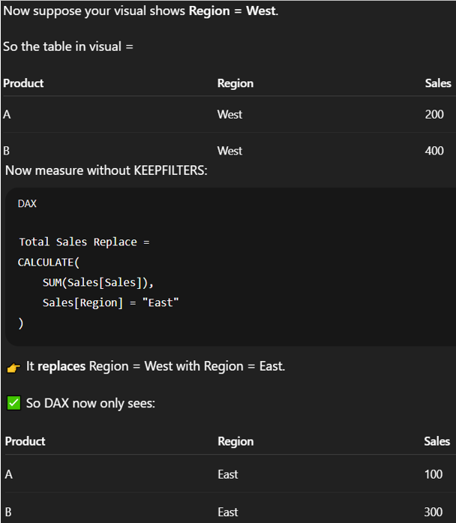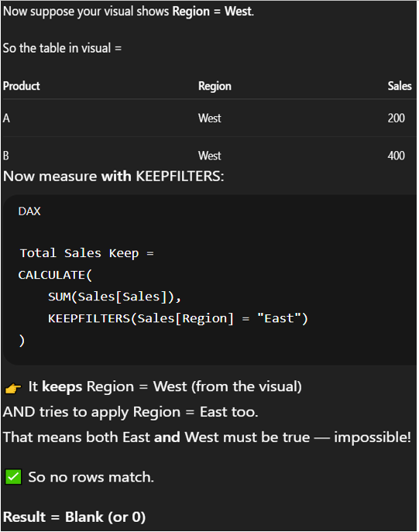
FILTERS():
It works as Current selection in QlikView (used to see what filters applied on specified columns).
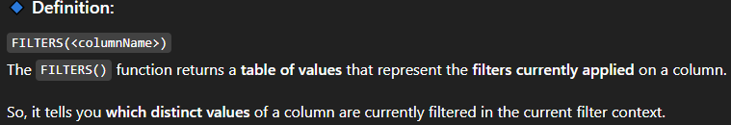
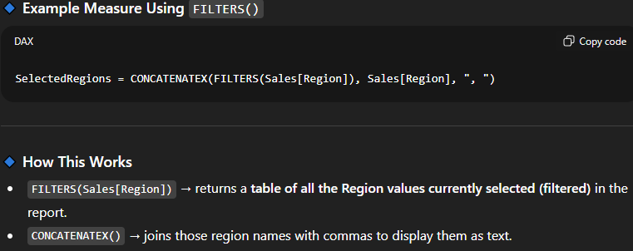
ALL() VS REMOVEFILTERS ():
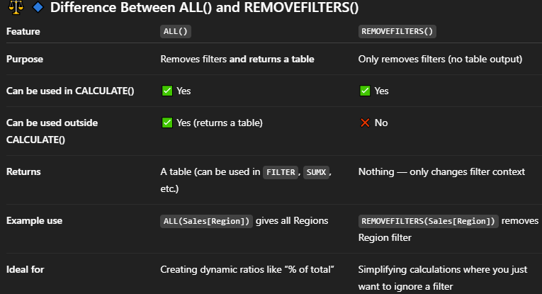
SELECTEDVALUES():
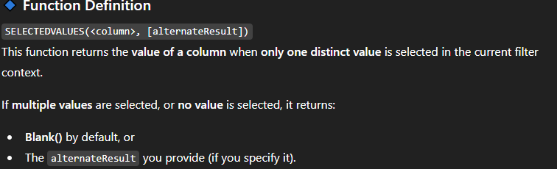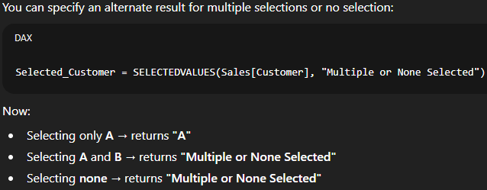
HASONEFILTER()
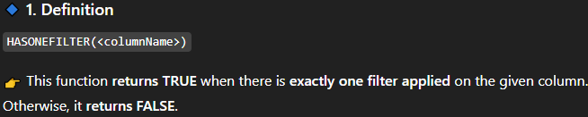
When the data is very heavy and we don’t want to show all the data for all the years then in that case we can put some condition that only if SINGLE value is selected from the specified columns then only create the KPIs otherwise not then to achieve this we can use this HASONEFITLER because this will return True only when single value from the column is selected and return false if no value or multiple values are selected.
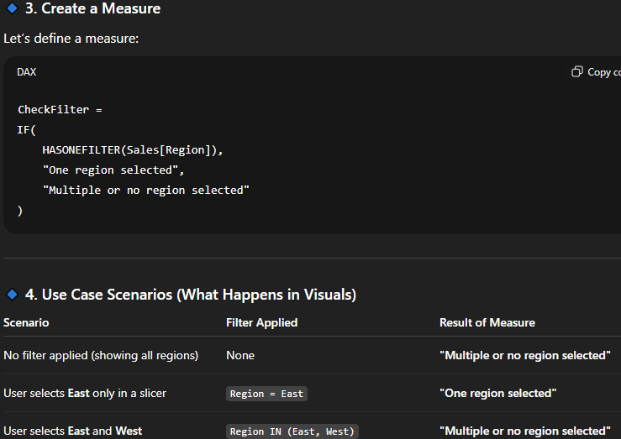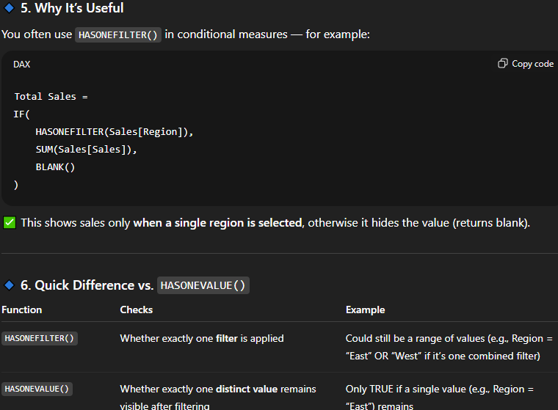
VALUES():
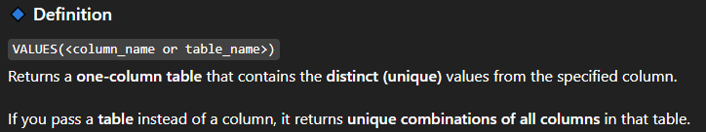
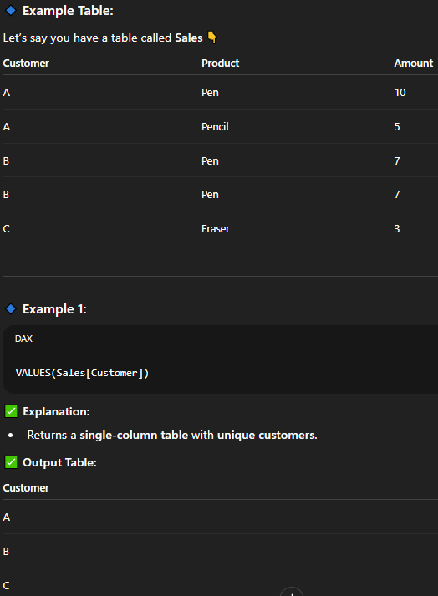
AND () / OR () / IF() / IFERROR():
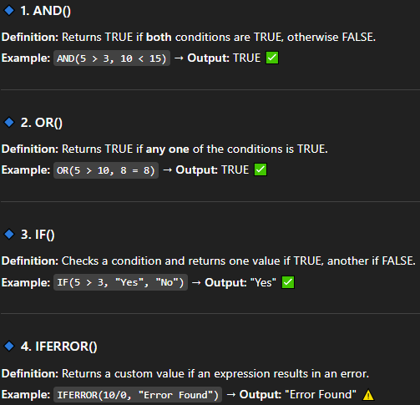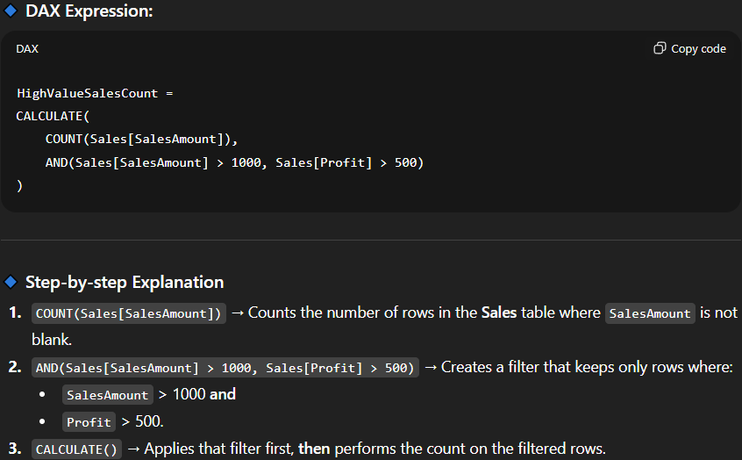
TRUE() / False() / NOT():
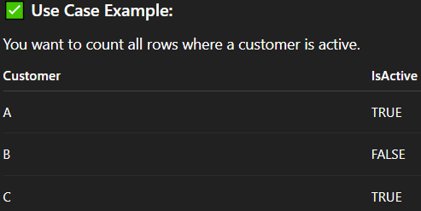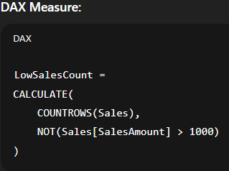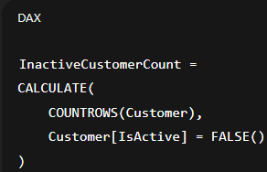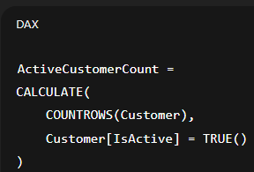
SWITCH():
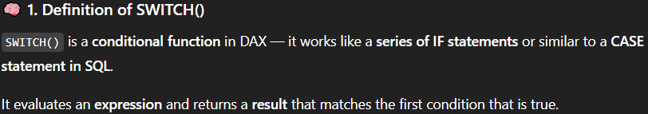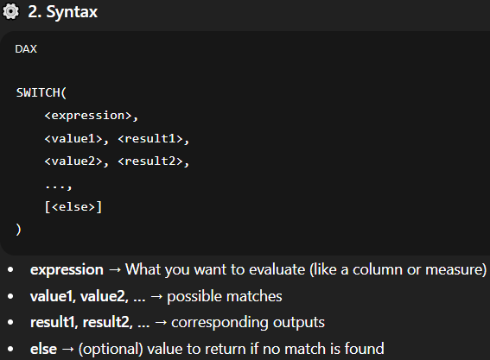
Examples():
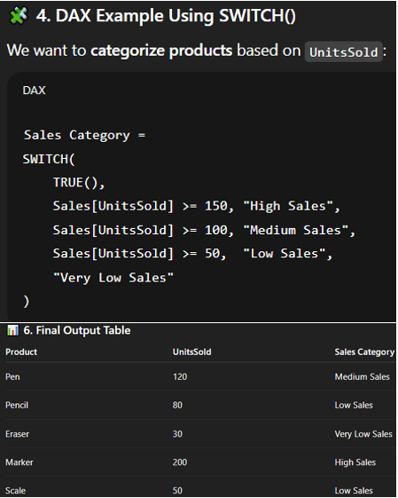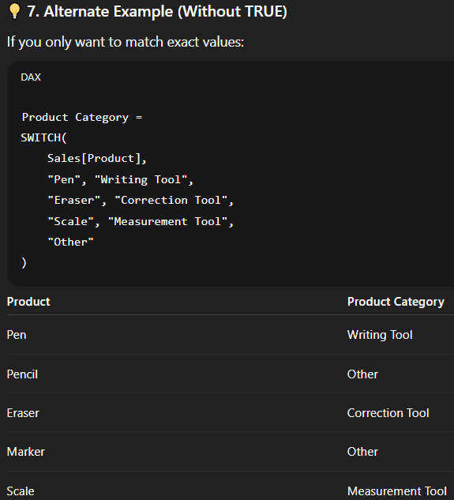
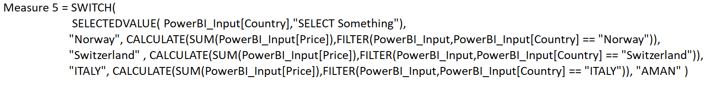
The above example has hardcoded values but then you can make it dynamic by using below query.

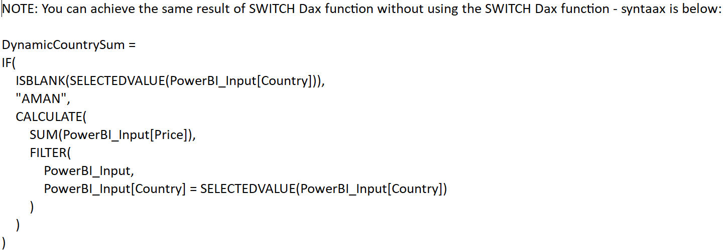

Example to practice:
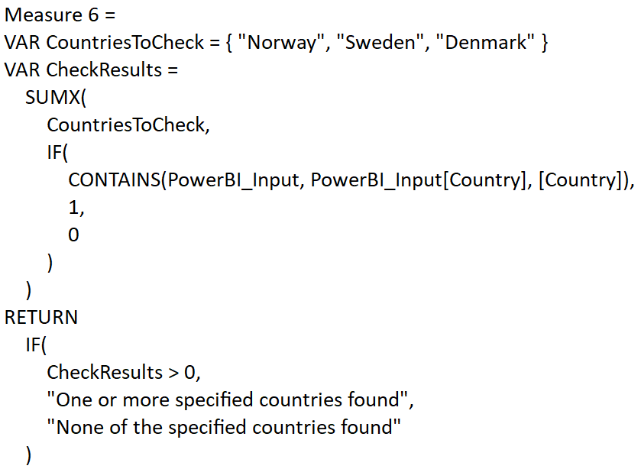
Explanation: NOTE:
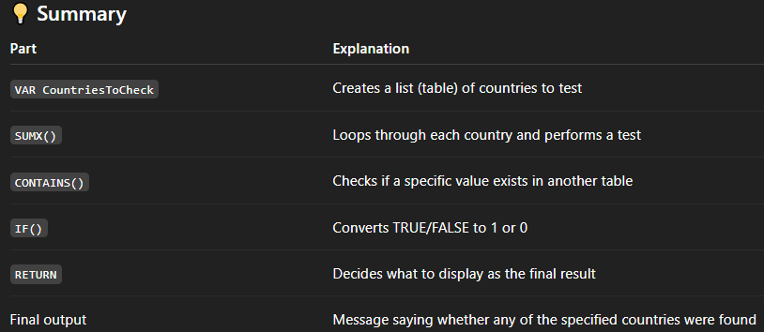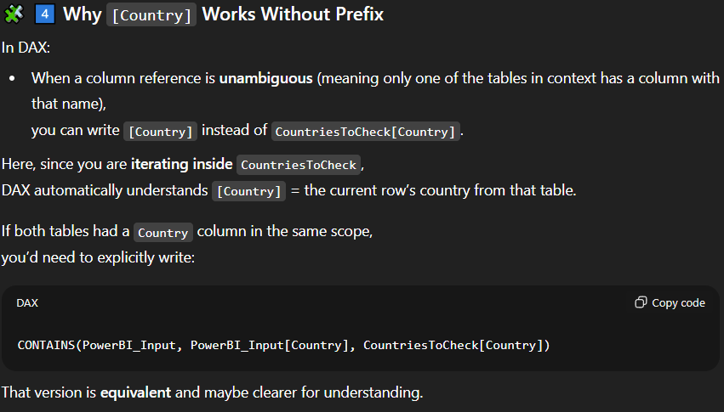
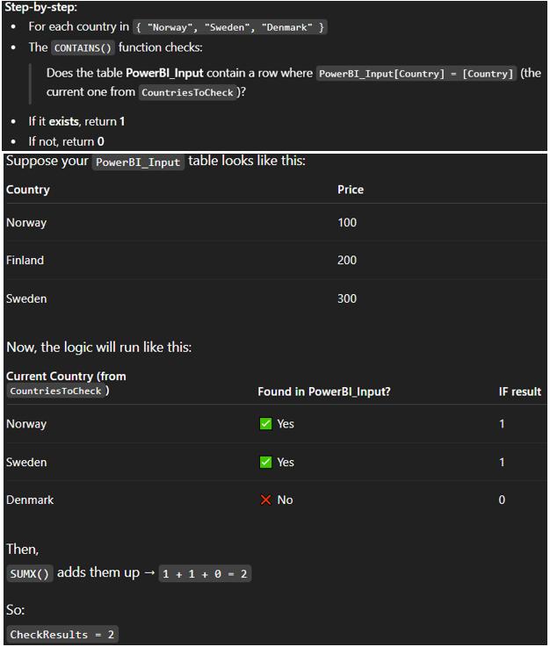
CONTAINS ():
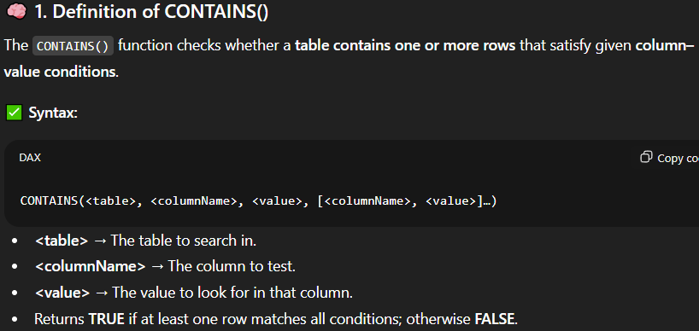
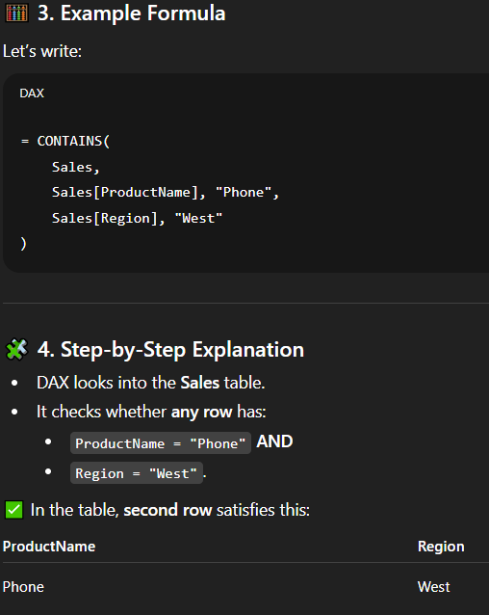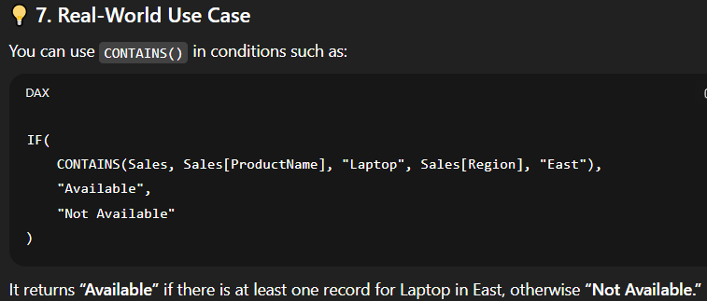
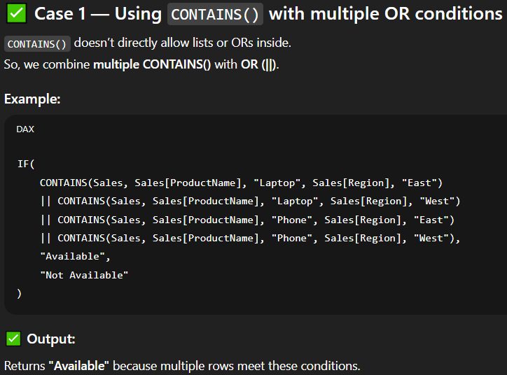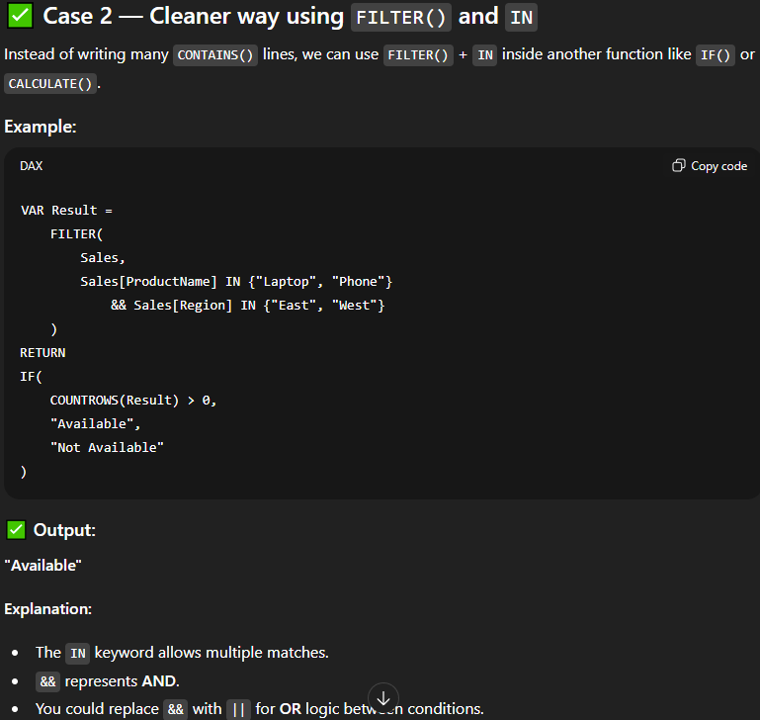
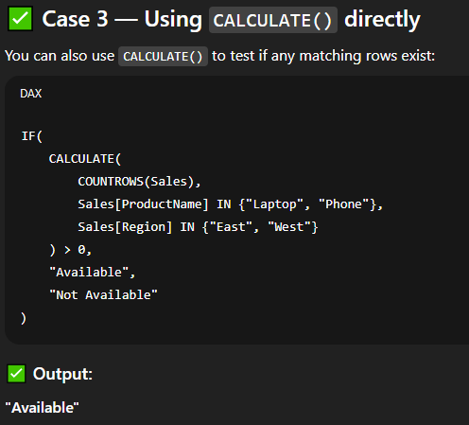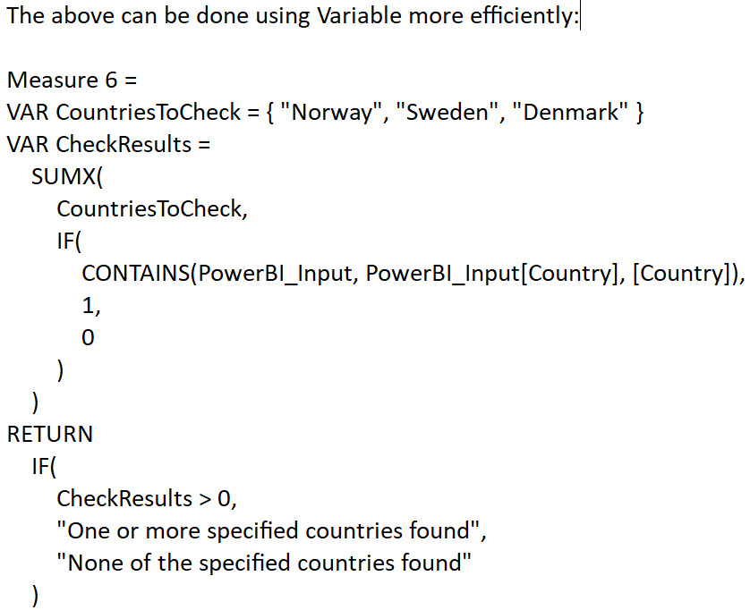
LOOKUPVALUE():

